Module 03 Lab 01 Used Car EDA Screenshot Evidence and Discussion
Reference label for this notebook: Lab1 (each heading below is numbered Lab1_1, Lab1_2 and so on).
This document collects the screenshots for Module 03 Lab 01, exploratory data analysis of used car prices, and heads each one after the section or question it belongs to so the notebook can be traced from the first import to the final correlation test. The notebook reads automobileEDA.csv, 201 rows and 29 columns, and works through importing the data, visualising individual features, descriptive statistics, grouping and pivot tables, and correlation with price. Every screenshot file name appears below its image.

Lab1_1. Section 1 Importing automobileEDA.csv and previewing the data
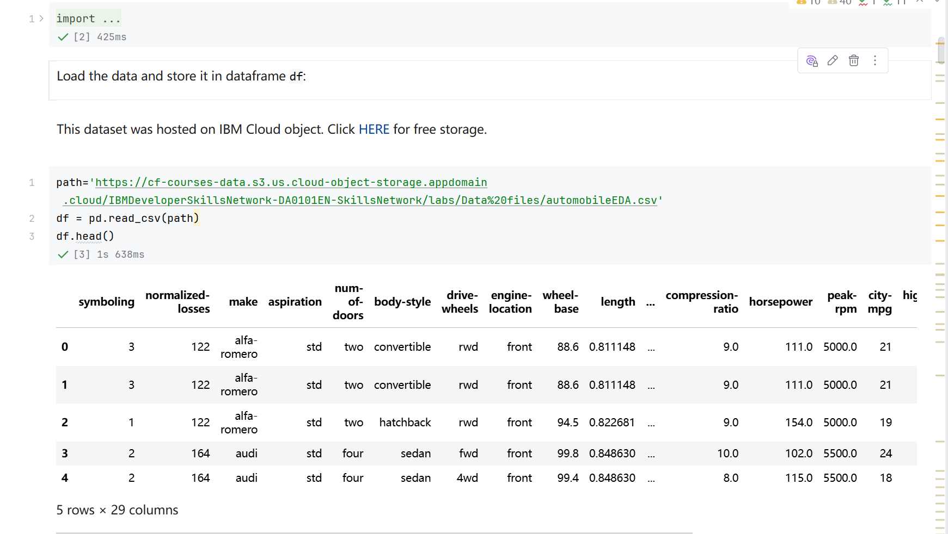
Screenshot file: 01_read_csv_automobileEDA_and_df.head.png
(image width 16.4 cm, scale to fit)
The cell reads the prepared automobile dataset from the course URL and df.head() shows the first rows, confirming 201 rows and 29 columns including the normalised dimensions and the city fuel consumption column.

Lab1_2. Section 2 Listing the data types before choosing plots
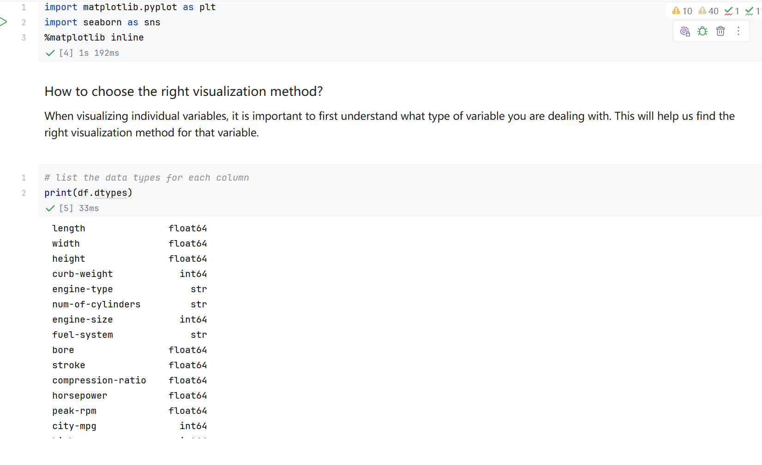
Screenshot file: 02_print_df.dtypes.png
(image width 16.4 cm, scale to fit)
print(df.dtypes) records which columns are continuous and which are categorical, the basis for choosing between regression plots and box plots.

Lab1_3. Question 1 Data type of the peak-rpm column
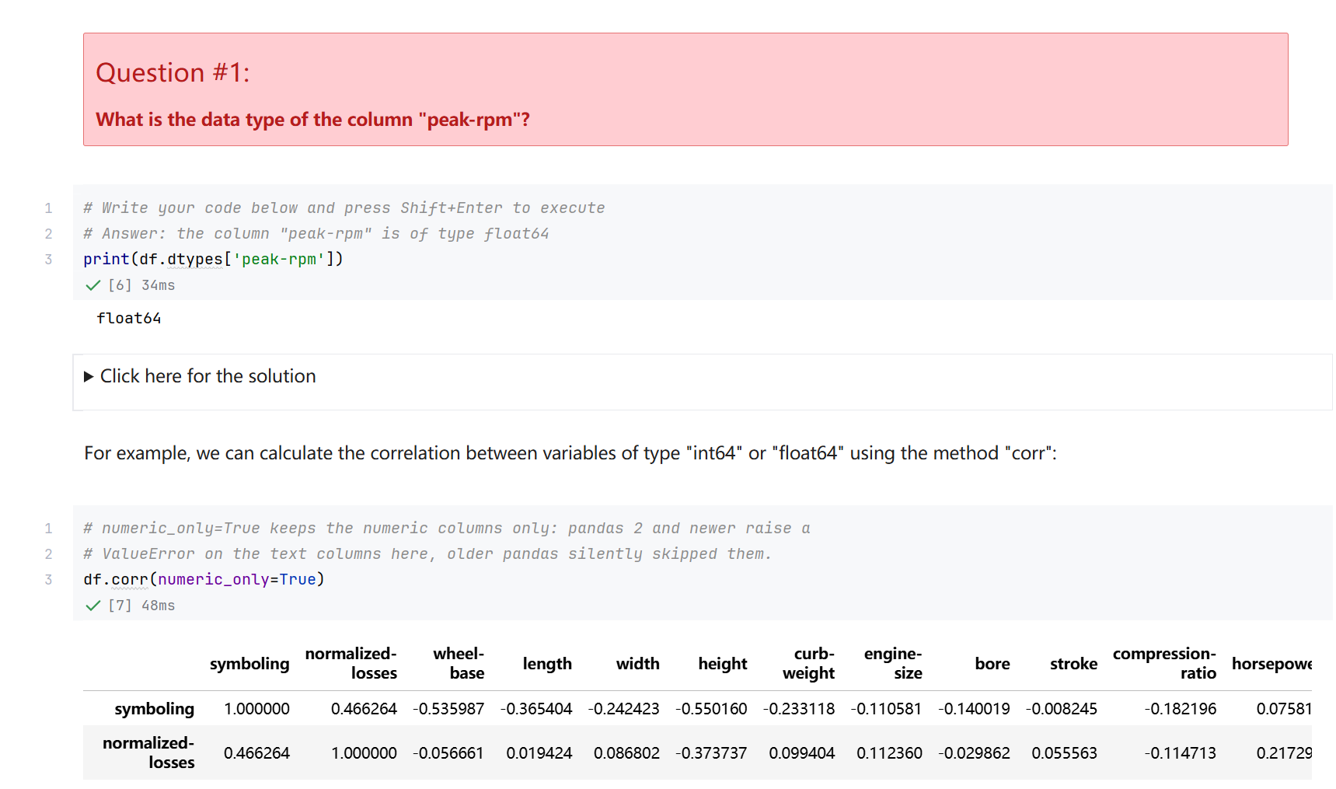
Screenshot file: 03_Q1_print_df.dtypes_peak-rpm.png
(image width 16.4 cm, scale to fit)
The answer cell prints the dtype of peak-rpm and returns float64, so peak-rpm is a continuous numerical variable.

Lab1_4. Section 2 Correlation matrix of the numeric columns
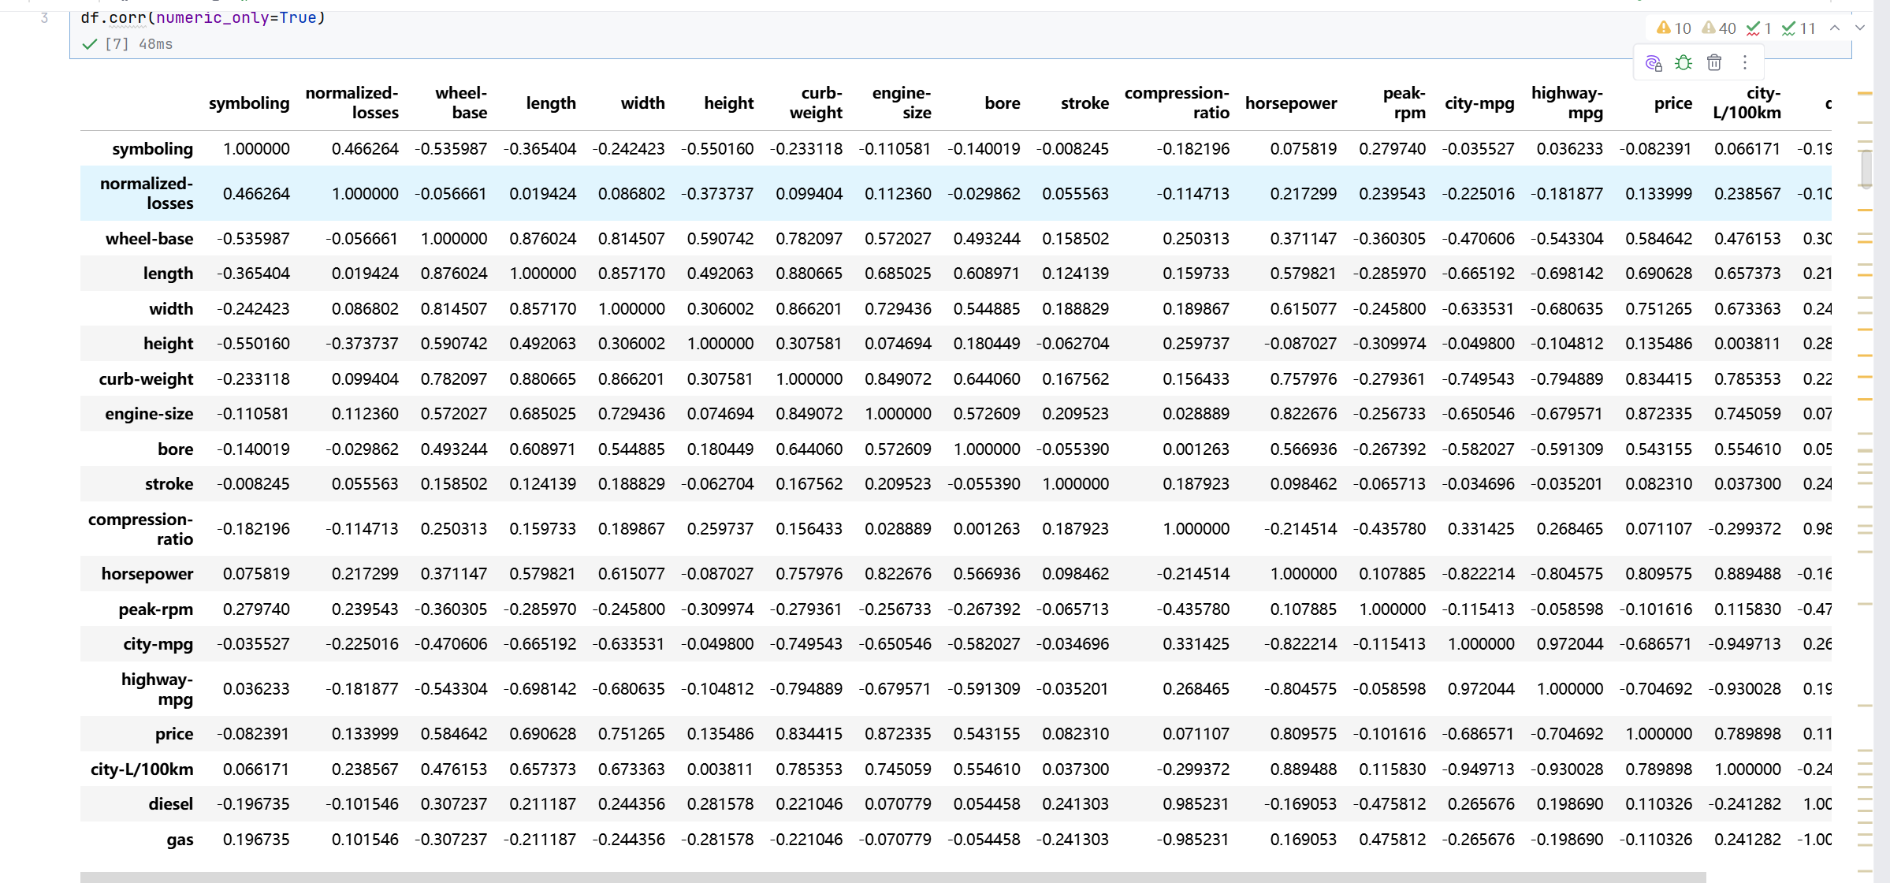
Screenshot file: 04_corr_numeric_only.png
(image width 16.4 cm, scale to fit)
df.corr(numeric_only=True) returns the pairwise Pearson correlations. The numeric_only argument keeps the text columns out of the calculation and is required from pandas 2 onwards.

Lab1_5. Question 2 Correlation between bore, stroke, compression-ratio and horsepower
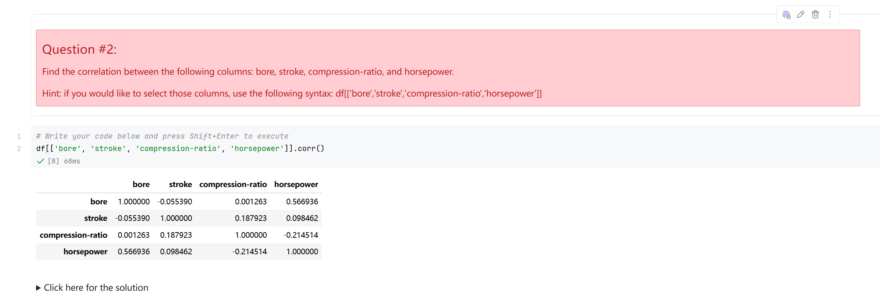
Screenshot file: 05_Q2_corr_bore_stroke_compression-ratio_horsepower.png
(image width 16.4 cm, scale to fit)
The four requested columns are selected and their correlation table is printed; horsepower correlates most strongly with bore at about 0.57, while stroke is almost independent.

Lab1_6. Section 2 Positive linear relationship between engine size and price
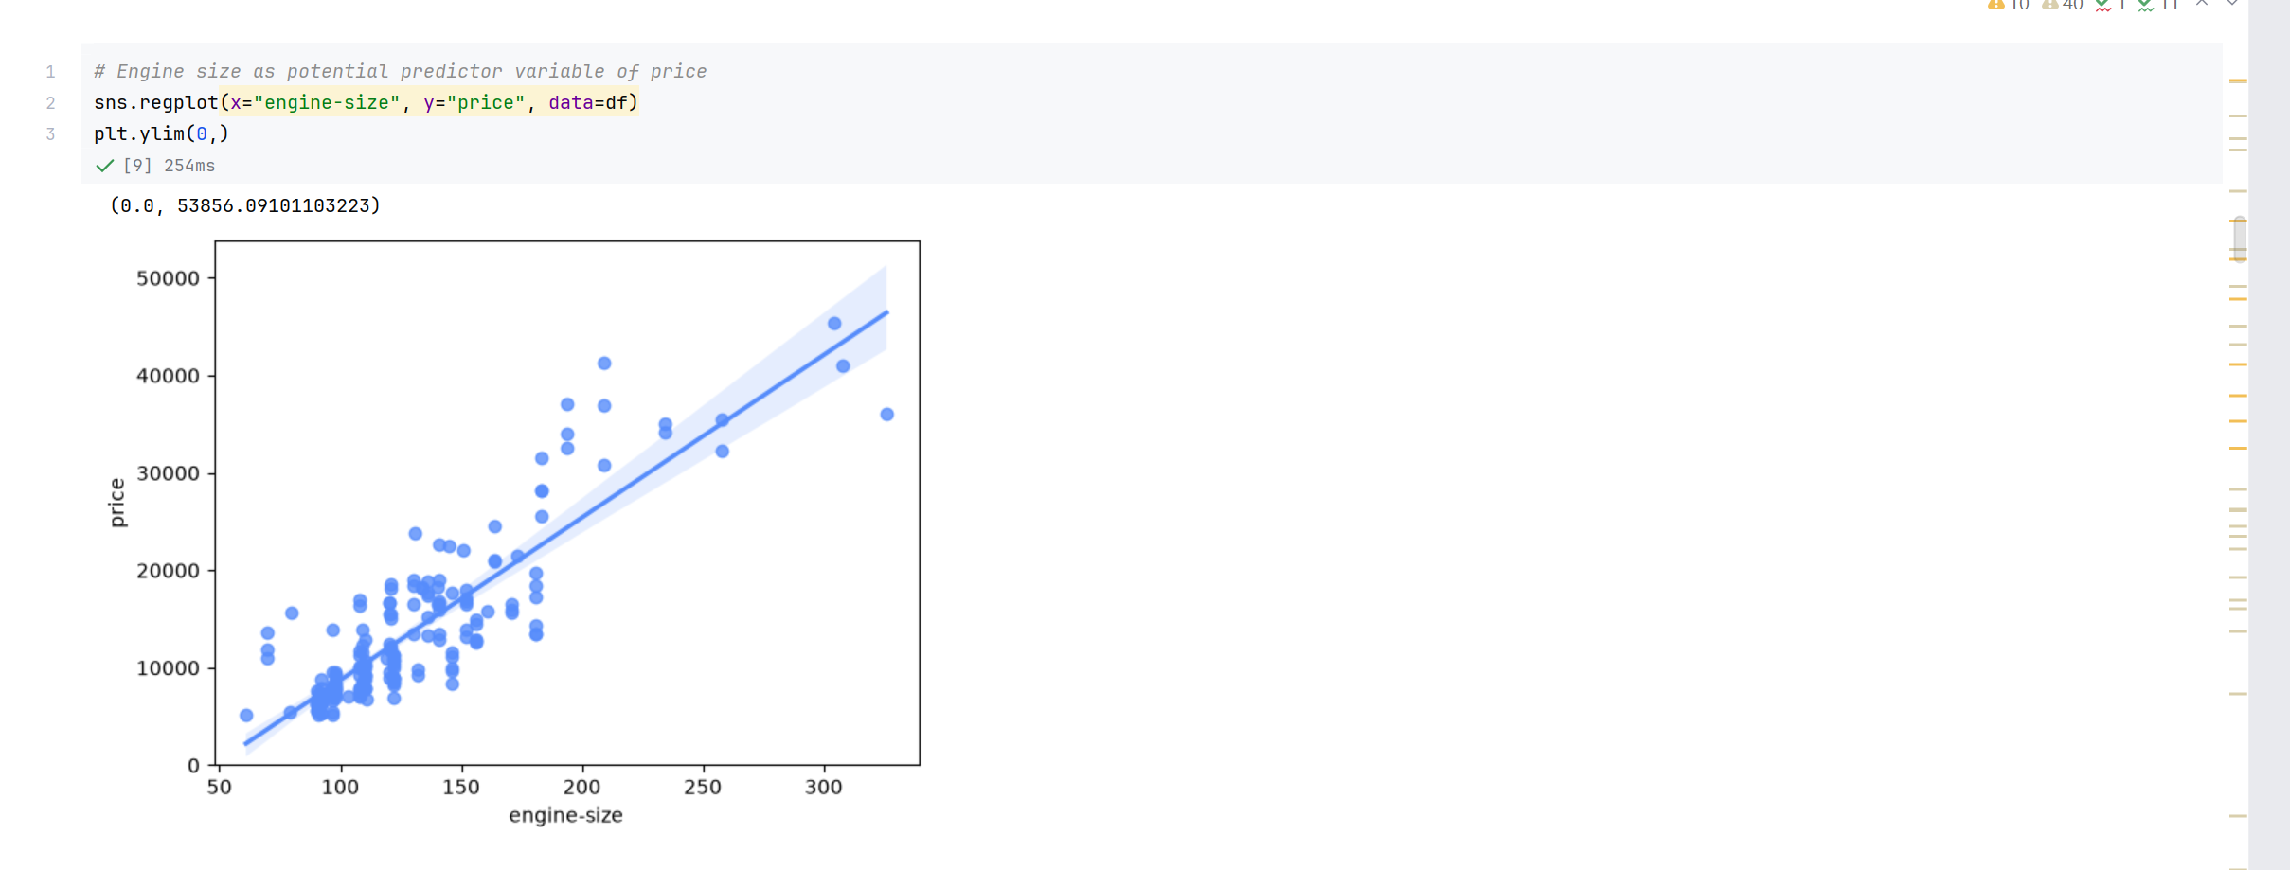
Screenshot file: 06_regplot_engine-size_vs_price.png
(image width 16.4 cm, scale to fit)
sns.regplot for engine-size against price shows a strong upward trend, one of the clearest single predictors of price in the dataset.

Lab1_7. Section 2 Negative relationship between highway mpg and price
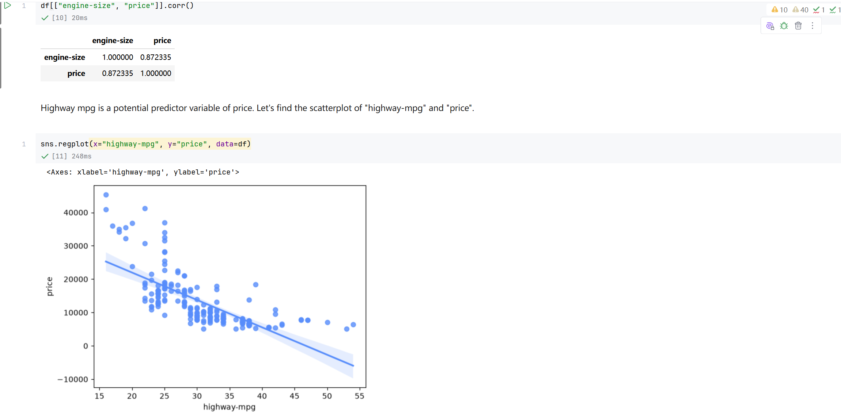
Screenshot file: 07_regplot_highway-mpg_vs_price.png
(image width 16.4 cm, scale to fit)
The regression plot for highway-mpg against price slopes downwards: as fuel consumption improves, the price falls.

Lab1_8. Section 2 Correlation of highway mpg with price
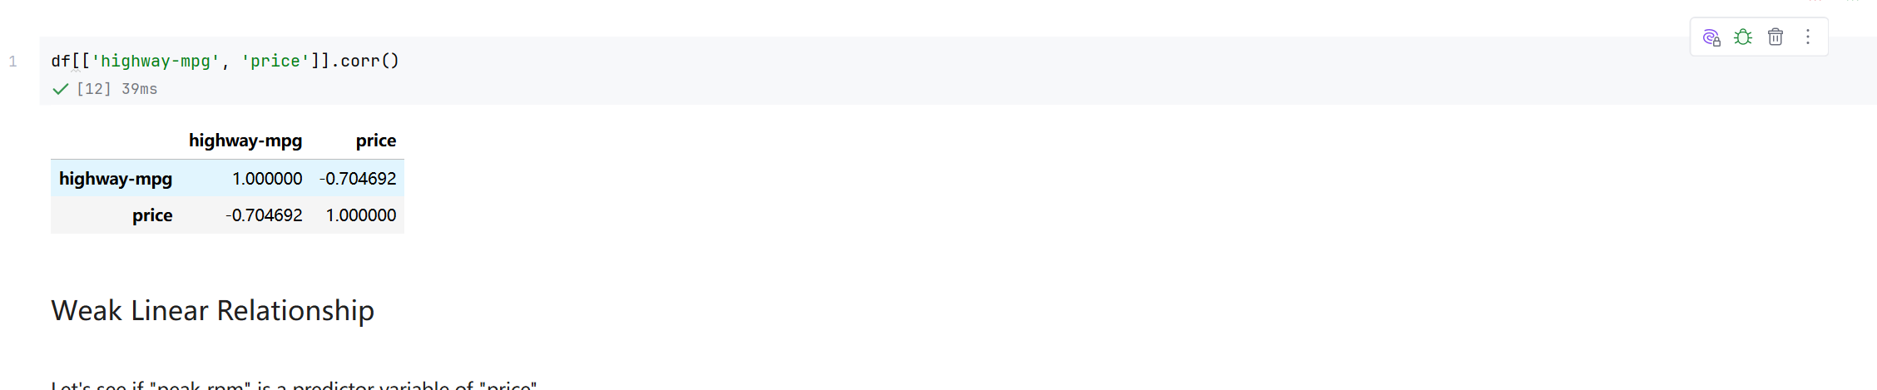
Screenshot file: 08_corr_highway-mpg_price.png
(image width 16.4 cm, scale to fit)
df[['highway-mpg','price']].corr() quantifies the relationship seen in the plot at about -0.705.

Lab1_9. Section 2 Weak relationship between peak rpm and price
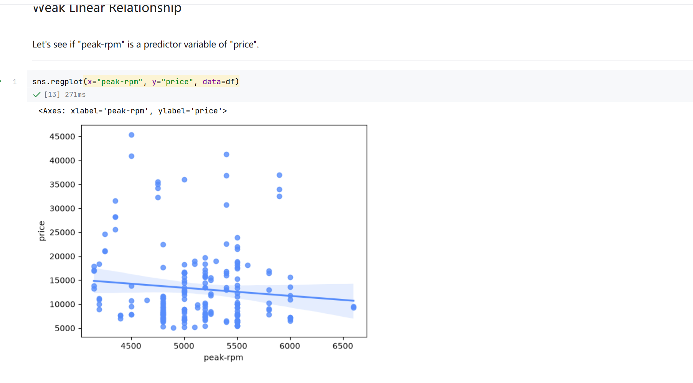
Screenshot file: 09_regplot_peak-rpm_vs_price.png
(image width 16.4 cm, scale to fit)
The regression plot for peak-rpm is almost horizontal with widely scattered points, so peak rpm is not a useful predictor.

Lab1_10. Section 2 Correlation of peak rpm with price
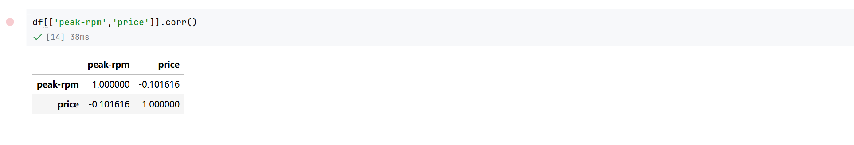
Screenshot file: 10_corr_peak-rpm_price.png
(image width 16.4 cm, scale to fit)
df[['peak-rpm','price']].corr() confirms the visual result with a coefficient of about -0.102.

Lab1_11. Question 3a Correlation between stroke and price
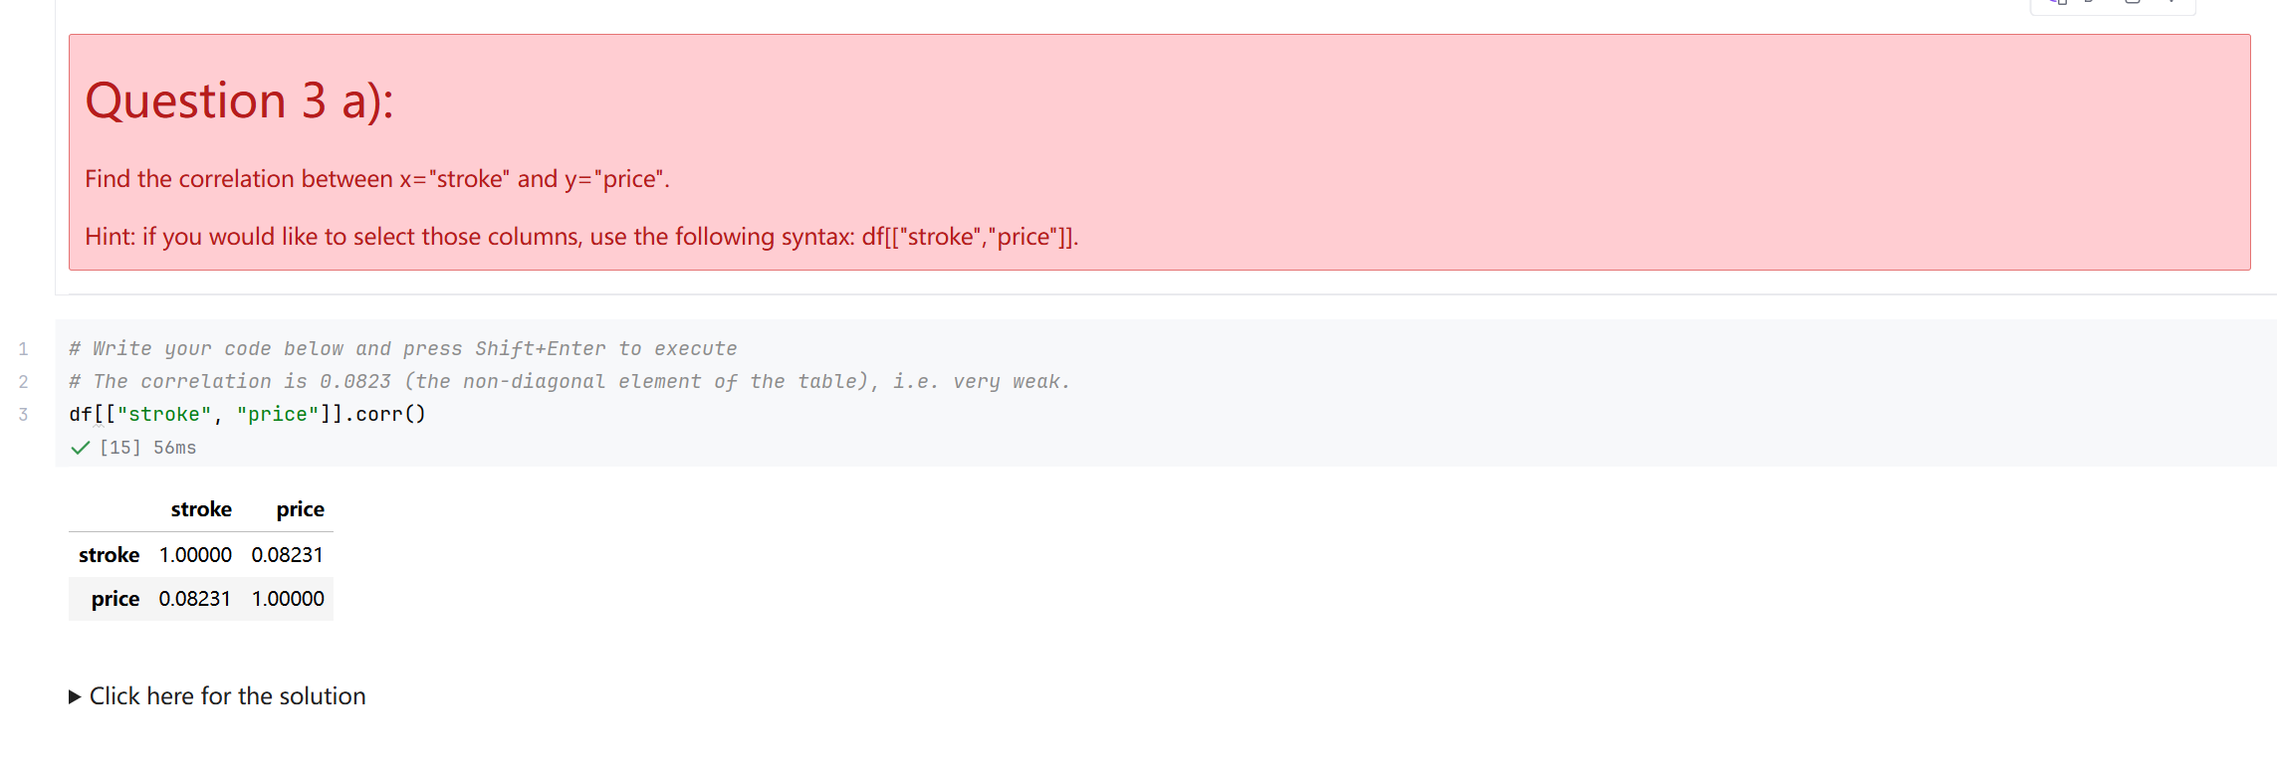
Screenshot file: 11_Q3a_corr_stroke_price.png
(image width 16.4 cm, scale to fit)
df[['stroke','price']].corr() gives 0.0823, an almost negligible linear relationship.

Lab1_12. Question 3b Verifying the stroke result with a regression plot
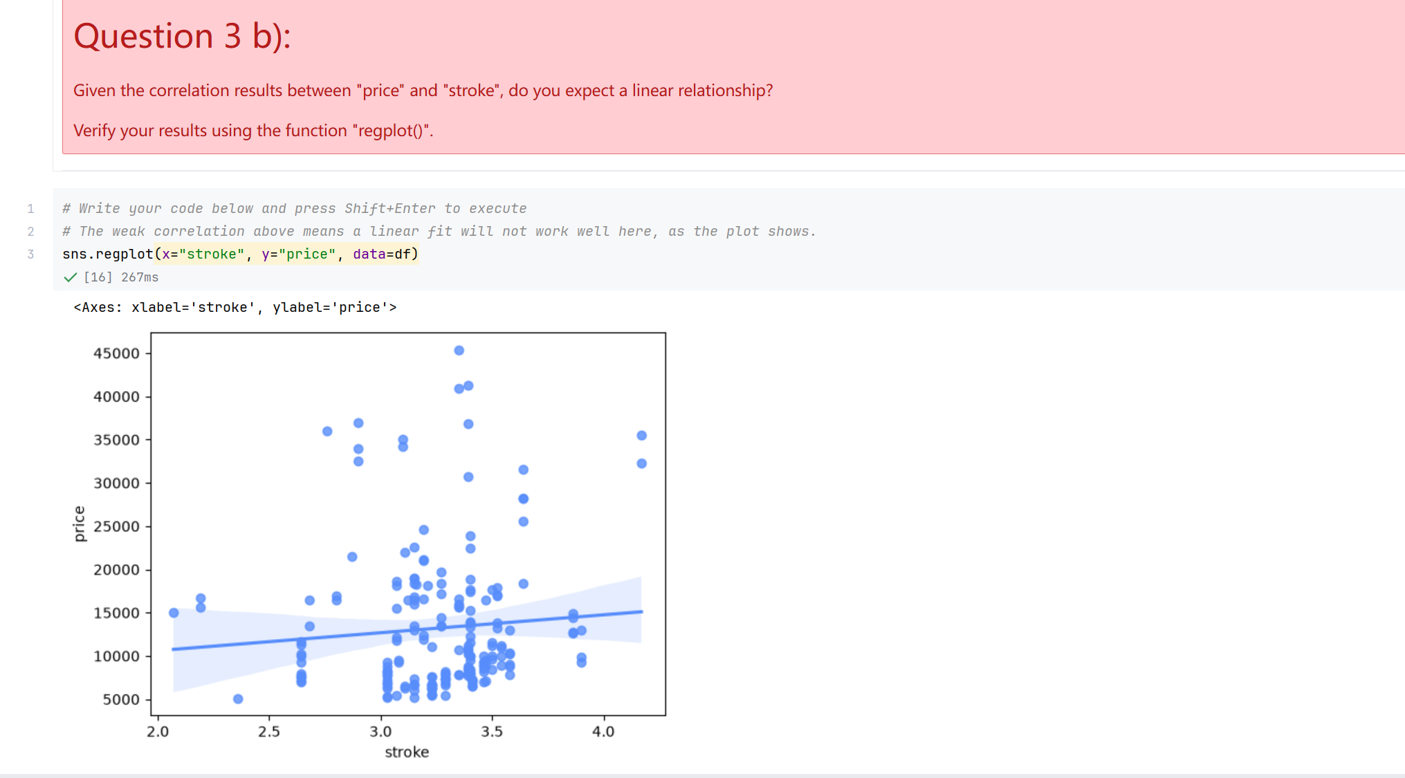
Screenshot file: 12_Q3b_regplot_stroke_vs_price.png
(image width 16.4 cm, scale to fit)
sns.regplot for stroke against price shows how flat and scattered the fit is, which agrees with the very low correlation from the previous question.

Lab1_13. Section 2 Box plot of price by body style
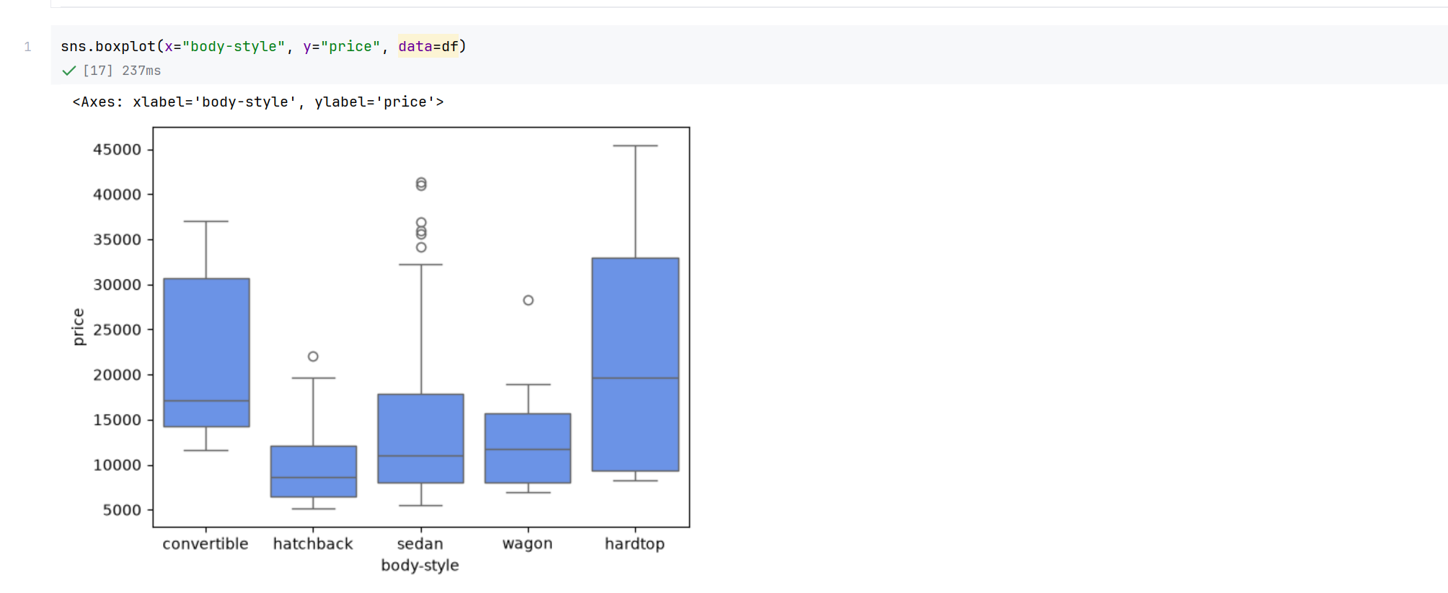
Screenshot file: 13_boxplot_body-style_vs_price.png
(image width 16.4 cm, scale to fit)
sns.boxplot for body-style against price shows that the price distributions of the five body styles overlap heavily, so body style on its own separates prices poorly.

Lab1_14. Section 2 Box plot of price by engine location
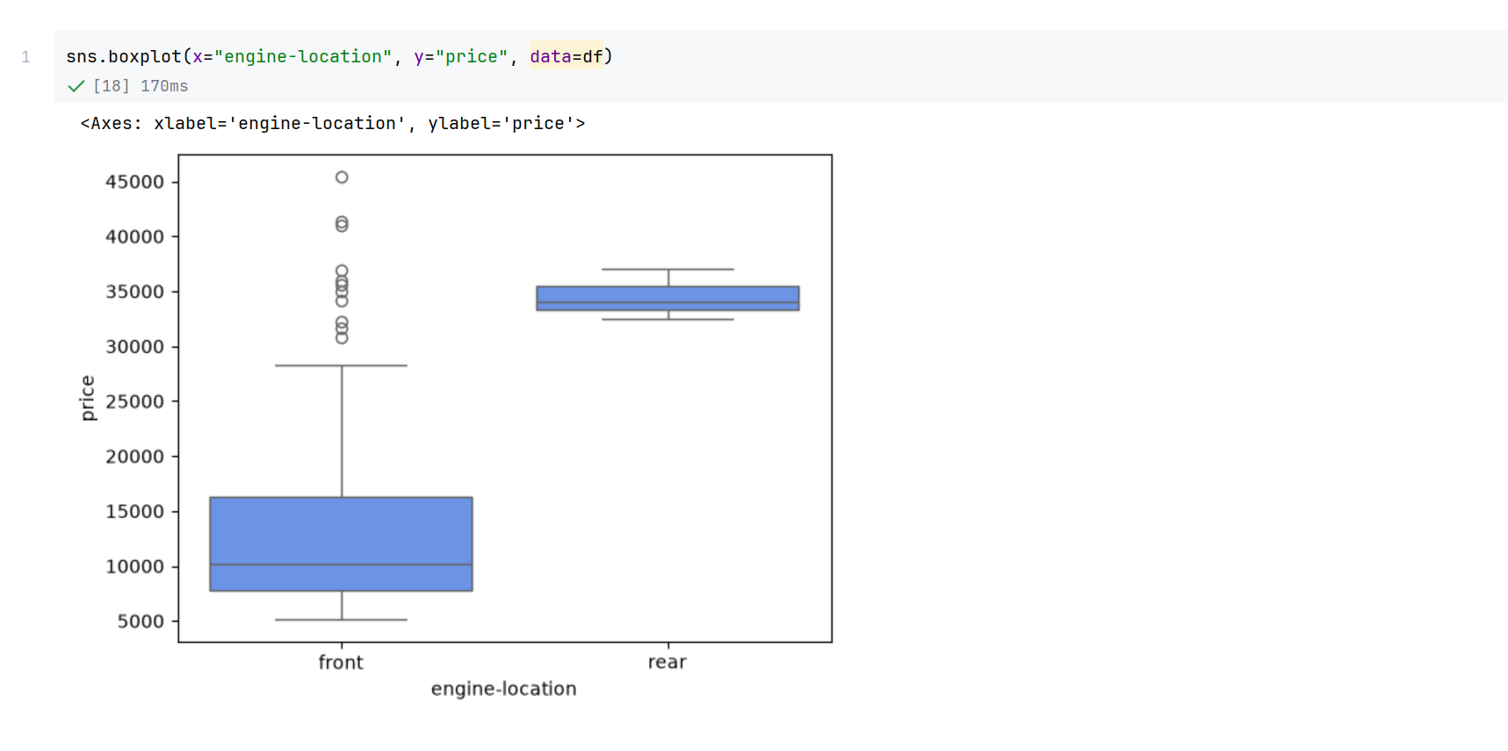
Screenshot file: 14_boxplot_engine-location_vs_price.png
(image width 16.4 cm, scale to fit)
The box plot for engine-location separates front and rear engines clearly, which makes engine location a promising categorical predictor.

Lab1_15. Section 2 Box plot of price by drive wheels
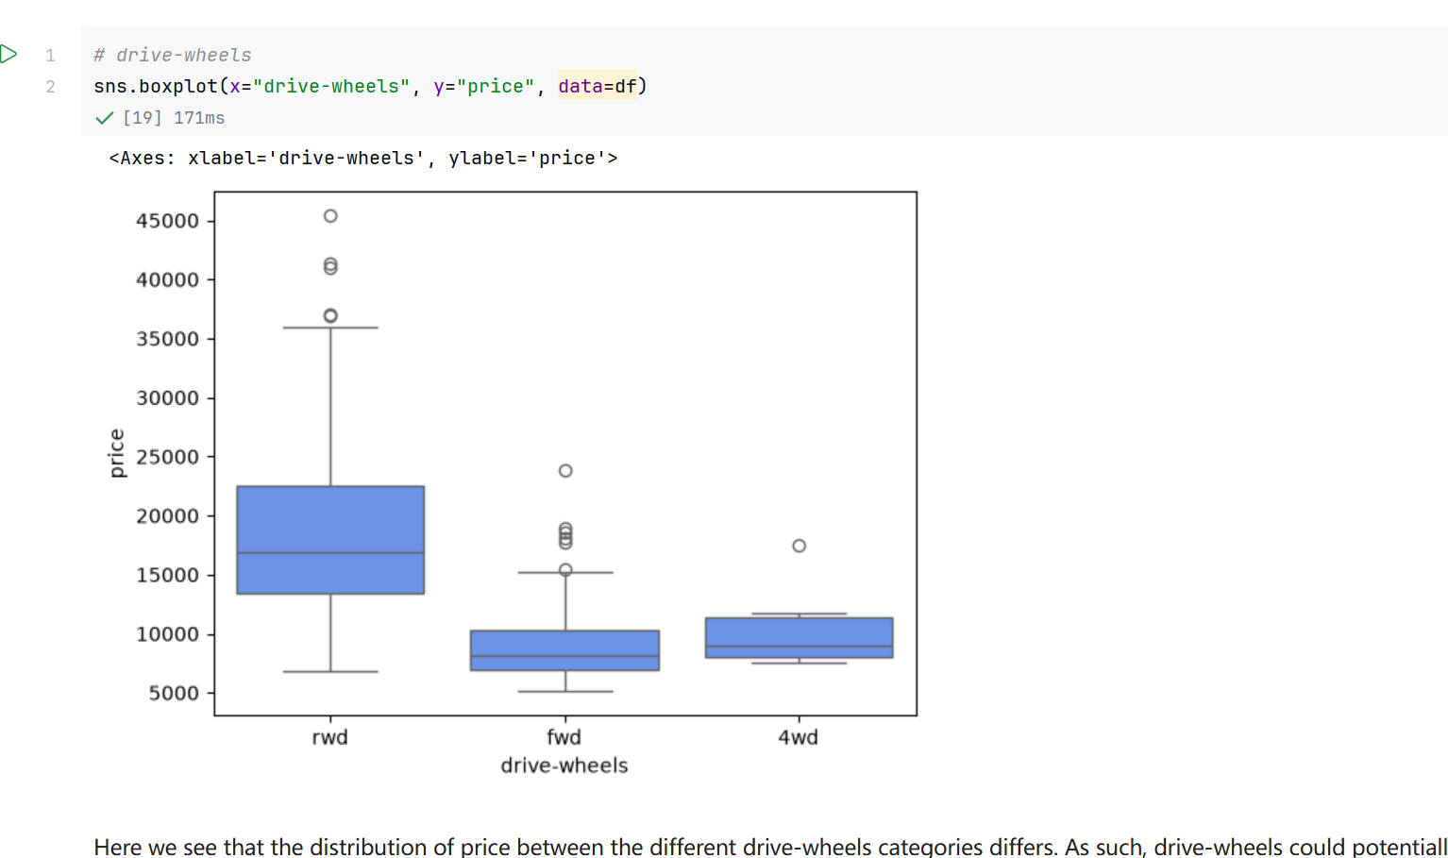
Screenshot file: 15_boxplot_drive-wheels_vs_price.png
(image width 16.4 cm, scale to fit)
The box plot for drive-wheels shows the three groups at visibly different price levels.

Lab1_16. Section 3 Descriptive statistics of the numeric attributes
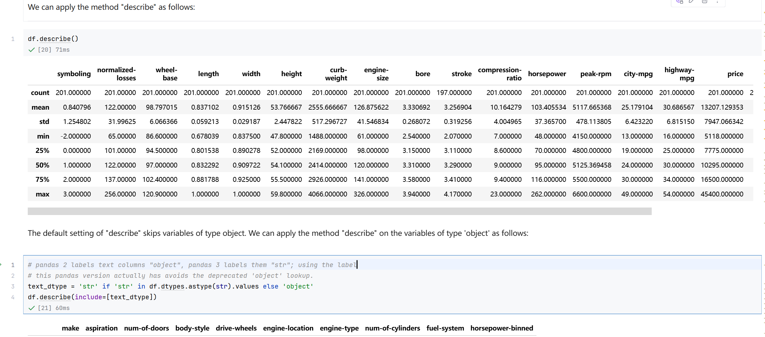
Screenshot file: 16_df.describe.png
(image width 16.4 cm, scale to fit)
df.describe() summarises the continuous variables and shows, for example, an average price of about 13207 and an average engine size of about 127.

Lab1_17. Section 3 Descriptive statistics including the text attributes
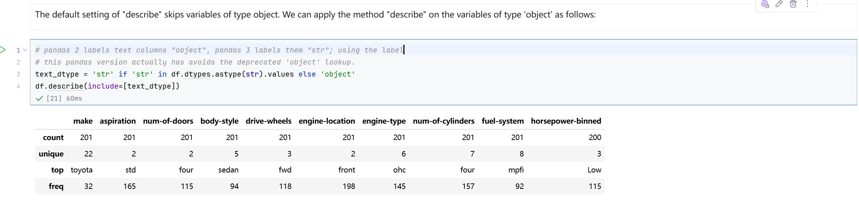
Screenshot file: 17_df.describe_include_object.png
(image width 16.4 cm, scale to fit)
The version that includes the object columns reports the frequency statistics of the categorical attributes such as make, body style and drive wheels.

Lab1_18. Section 3 Counting the values of drive wheels
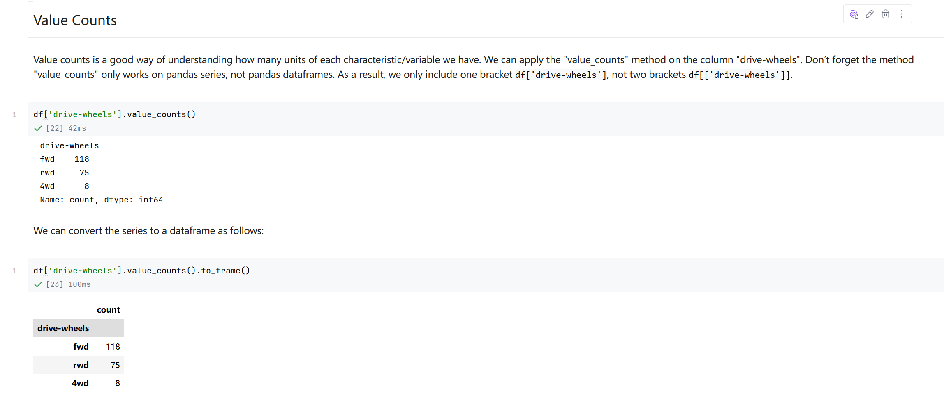
Screenshot file: 18_value_counts_drive-wheels.png
(image width 16.4 cm, scale to fit)
df['drive-wheels'].value_counts() counts how many cars fall into each drive wheel category, with front wheel drive dominating the sample.

Lab1_19. Section 3 Converting the drive wheel counts to a dataframe
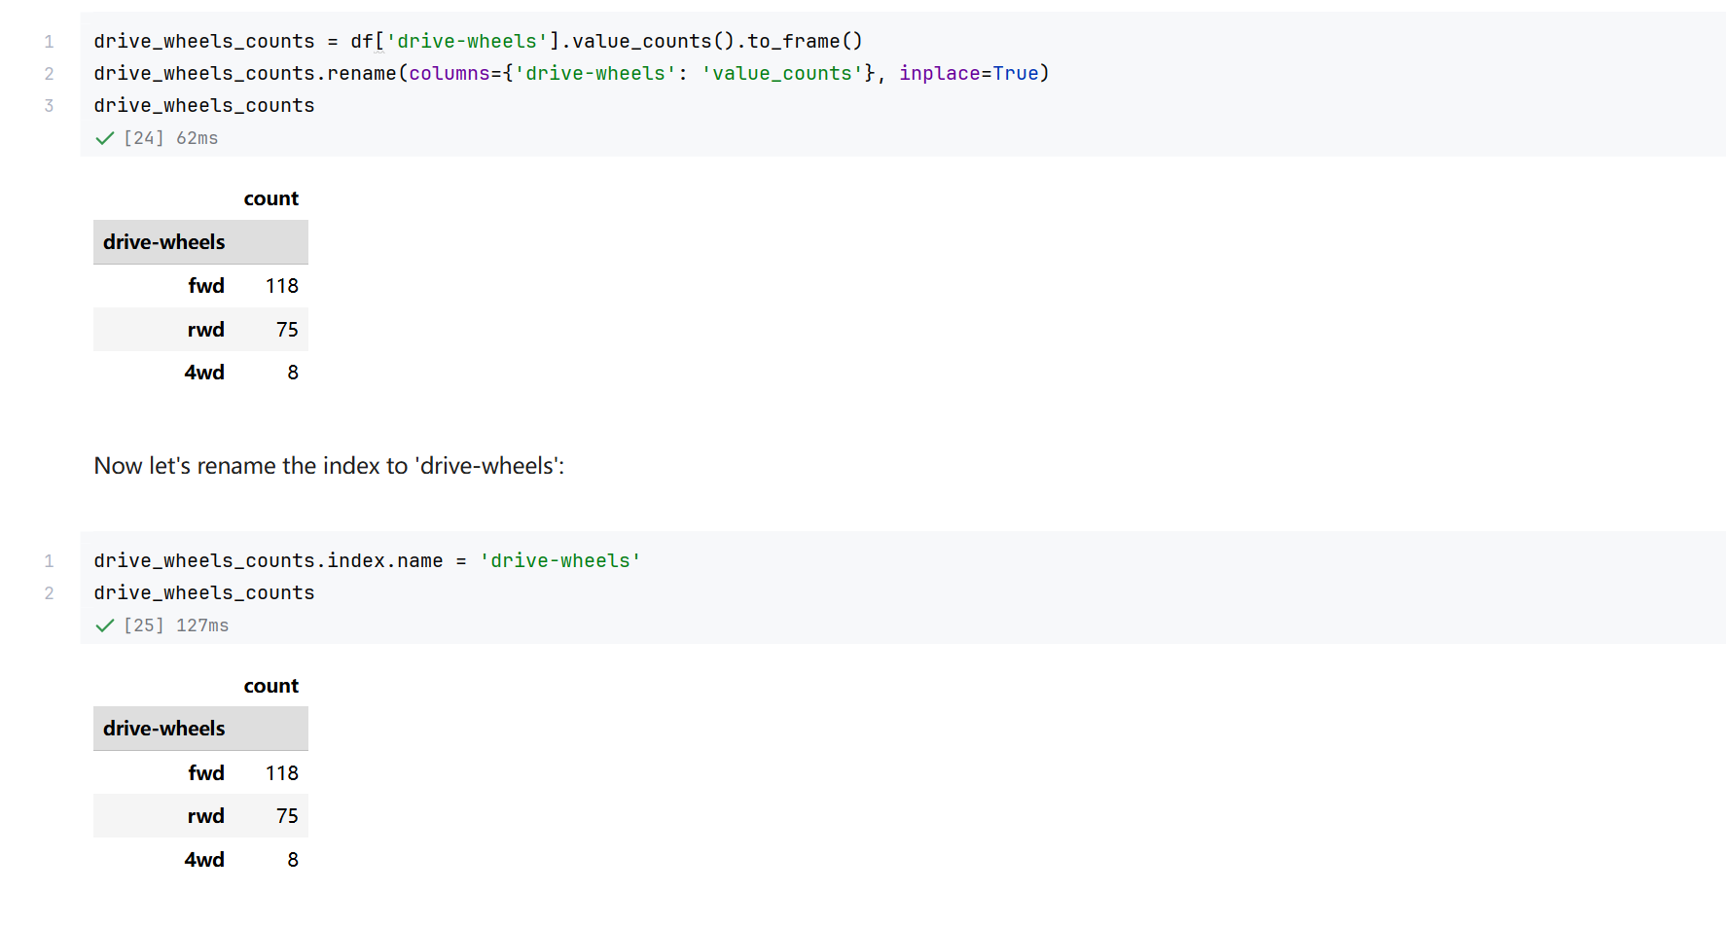
Screenshot file: 19_drive_wheels_counts_to_frame_and_rename.png
(image width 16.4 cm, scale to fit)
The counts are converted with to_frame() and the column is renamed to value_counts so the result can be read as a small table.

Lab1_20. Section 3 Counting the values of engine location
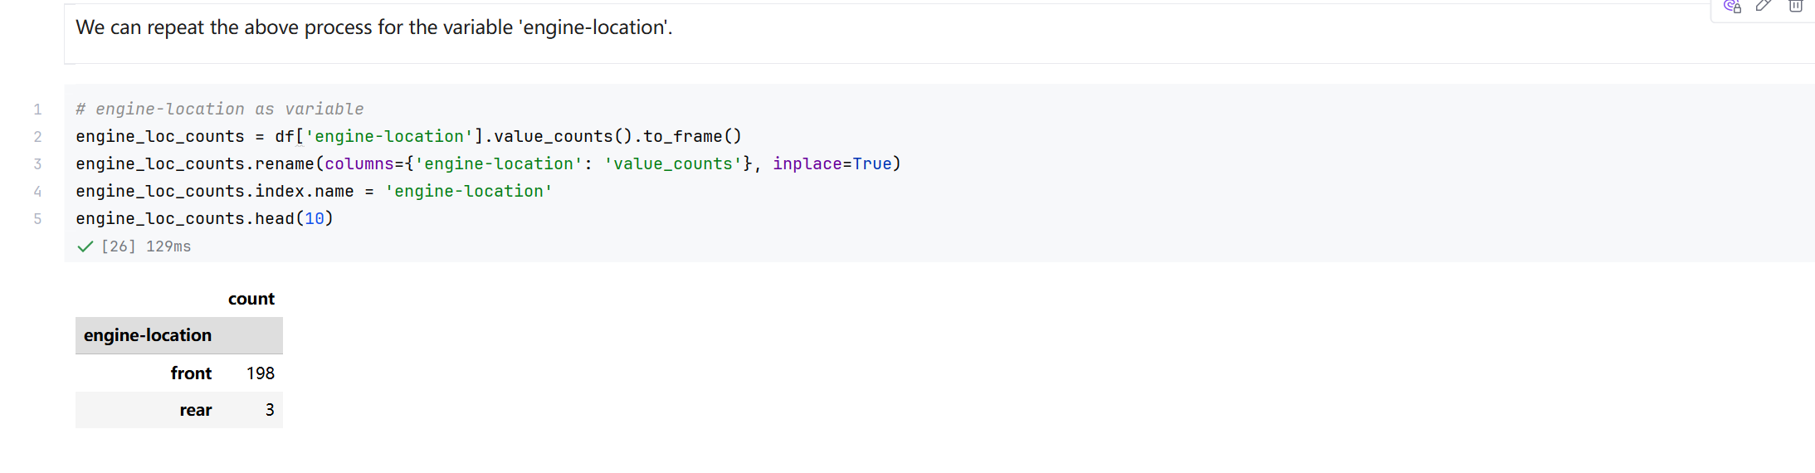
Screenshot file: 20_value_counts_engine-location_to_frame.png
(image width 16.4 cm, scale to fit)
The same sequence is repeated for engine-location and confirms the imbalance noted in the notebook: almost every car has its engine at the front.

Lab1_21. Section 4 Selecting the columns for the grouping analysis
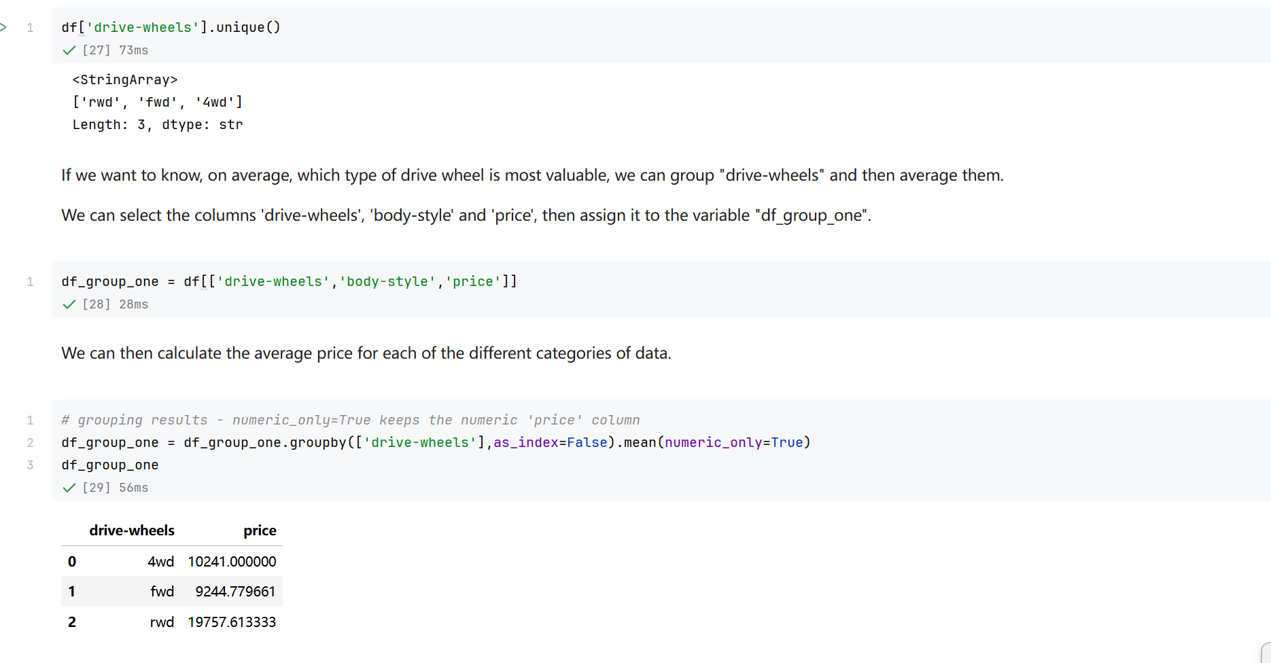
Screenshot file: 21_select_columns_drive-wheels_body-style_price.png
(image width 16.4 cm, scale to fit)
df_group_one selects drive-wheels, body-style and price, the three columns used for the first grouped analysis.

Lab1_22. Section 4 Average price by drive wheels
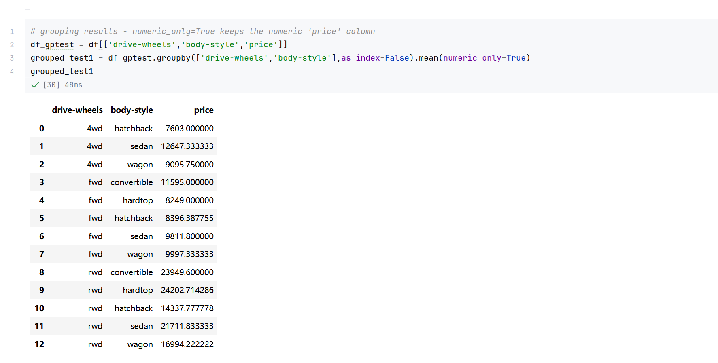
Screenshot file: 22_groupby_drive-wheels_body-style_mean.png
(image width 16.4 cm, scale to fit)
Grouping on drive-wheels with mean and numeric_only gives the average price of each group; rear wheel drive cars are the most expensive on average.

Lab1_23. Section 4 Grouping by drive wheels and body style
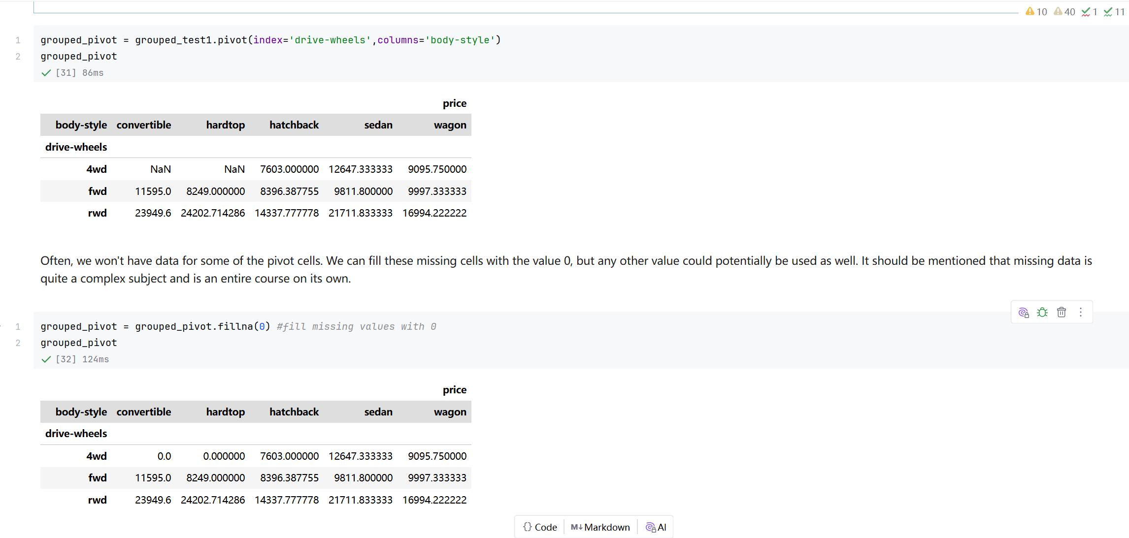
Screenshot file: 23_grouped_pivot_fillna_0.png
(image width 16.4 cm, scale to fit)
Grouping on the two categorical attributes produces the price for every drive wheel and body style combination, which is then reshaped into a pivot table.

Lab1_24. Question 4 Average price of each body style
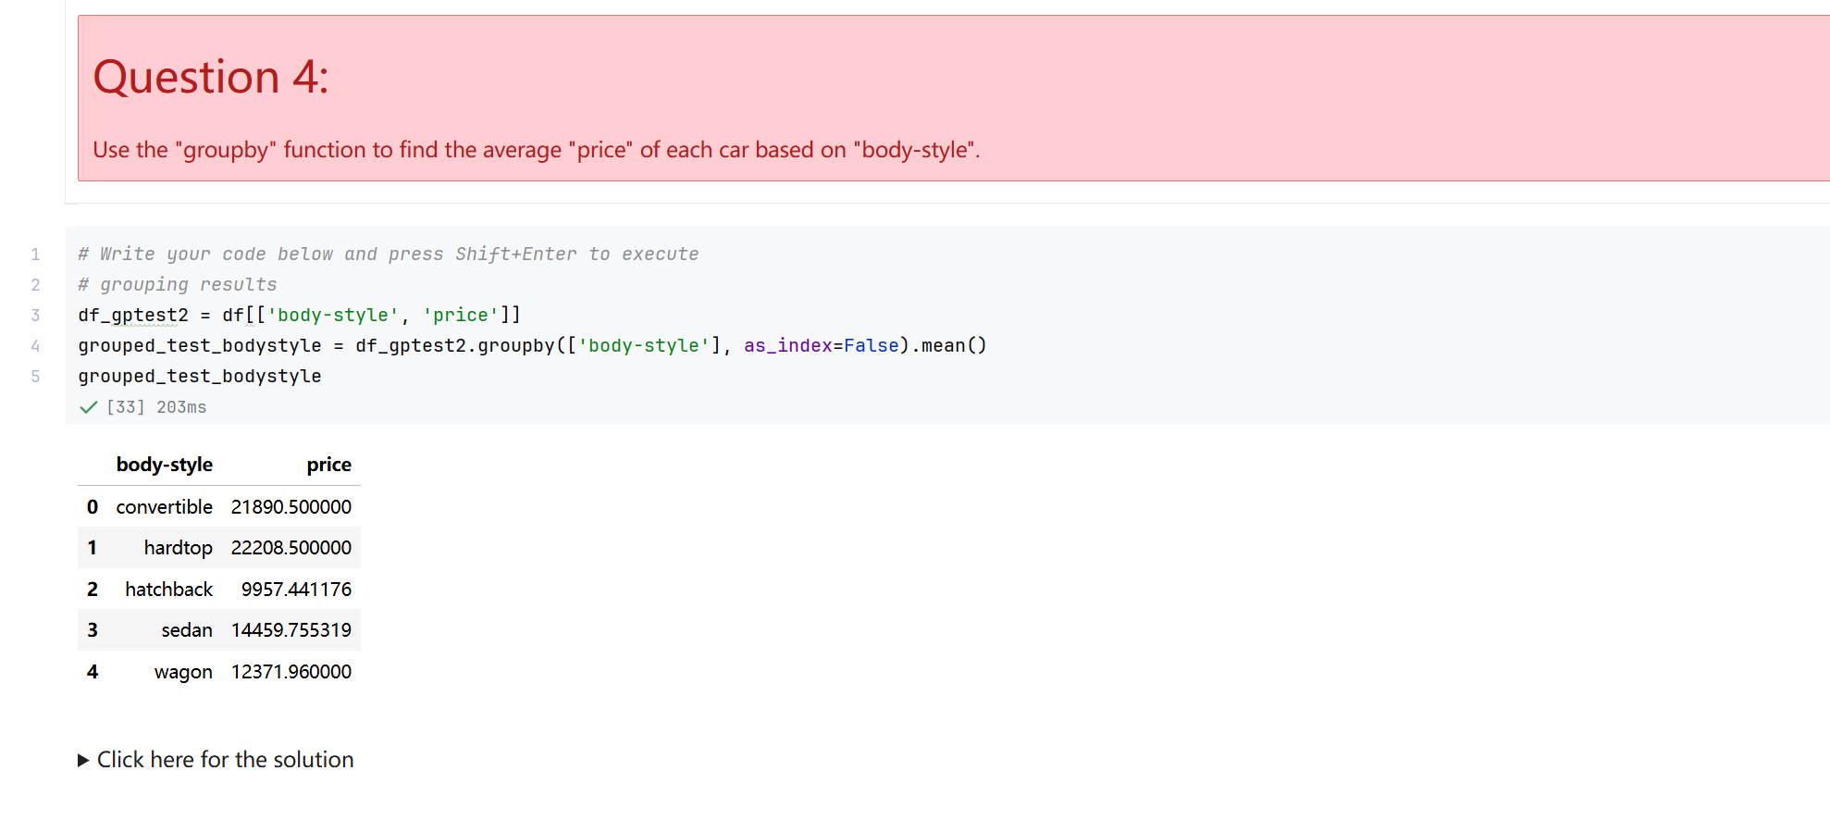
Screenshot file: 24_Q4_groupby_body-style_mean_price.png
(image width 16.4 cm, scale to fit)
df[['body-style','price']].groupby(['body-style'], as_index=False).mean() answers the question: convertibles and hardtops average over 21000, while hatchbacks average under 10000.

Lab1_25. Section 4 Importing matplotlib for the heat map
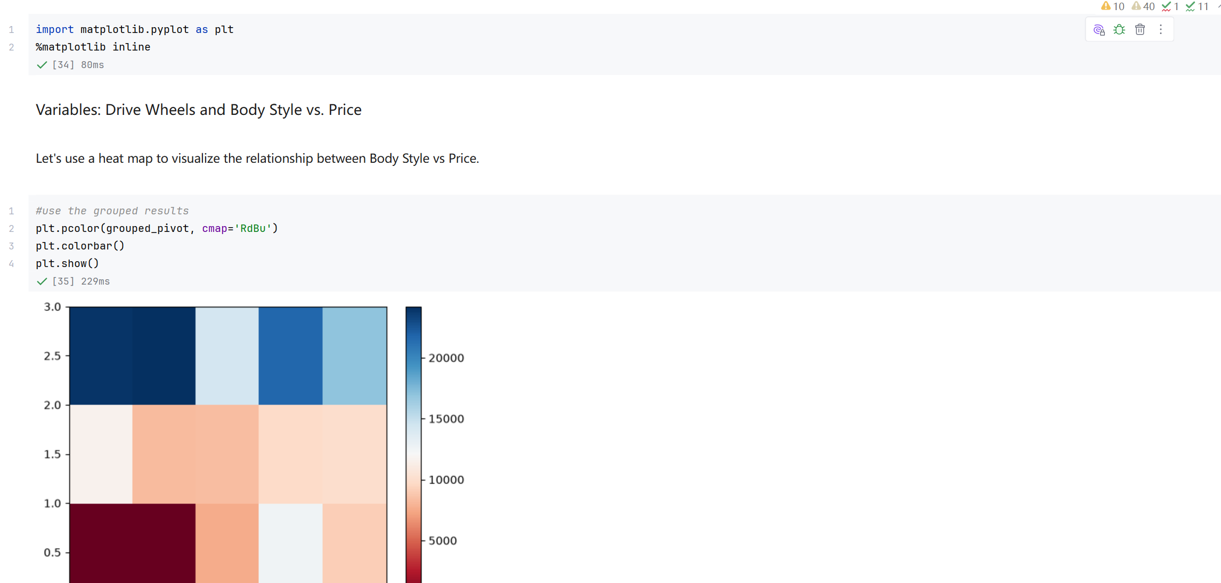
Screenshot file: 25_import_matplotlib_pyplot.png
(image width 16.4 cm, scale to fit)
matplotlib.pyplot is imported so the grouped result can be displayed as a colour coded heat map.

Lab1_26. Section 4 First heat map of the grouped prices
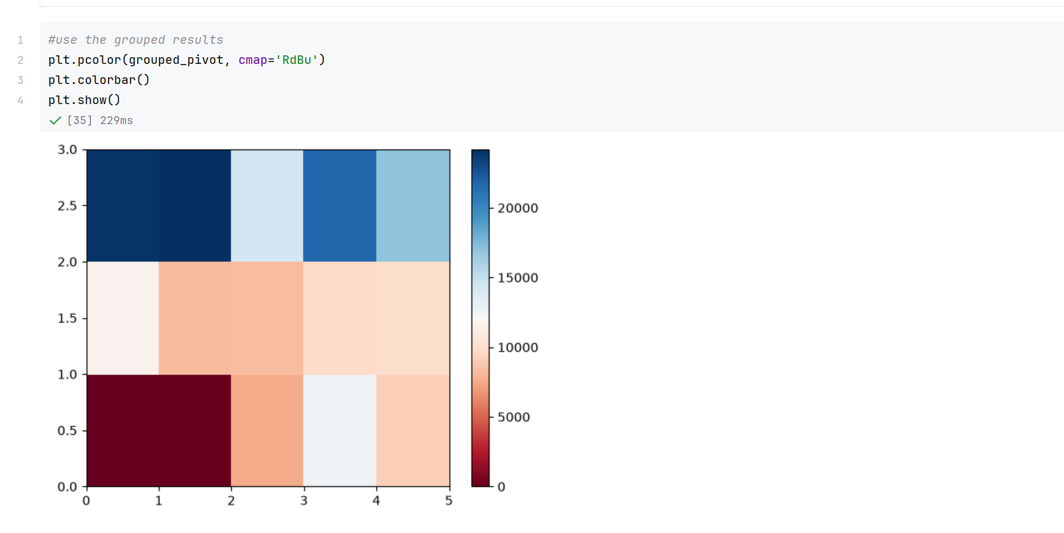
Screenshot file: 26_plt.pcolor_heatmap_grouped_pivot.png
(image width 16.4 cm, scale to fit)
plt.pcolor on the pivot table with the RdBu colour map turns the grouped prices into a grid, where red marks the expensive combinations and blue the cheaper ones.

Lab1_27. Section 4 Heat map with row and column labels
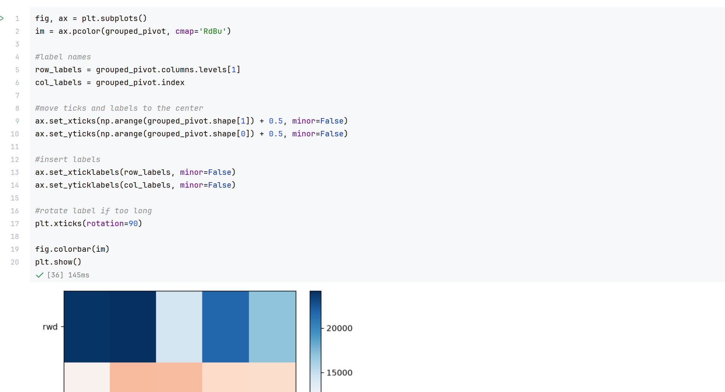
Screenshot file: 27_ax.pcolor_heatmap_with_labels.png
(image width 16.4 cm, scale to fit)
The second version replaces the default ticks with the drive wheel and body style labels and adds a colour bar, so the pattern in the table can be read directly.

Lab1_28. Section 4 The labelled heat map as it appears in the notebook
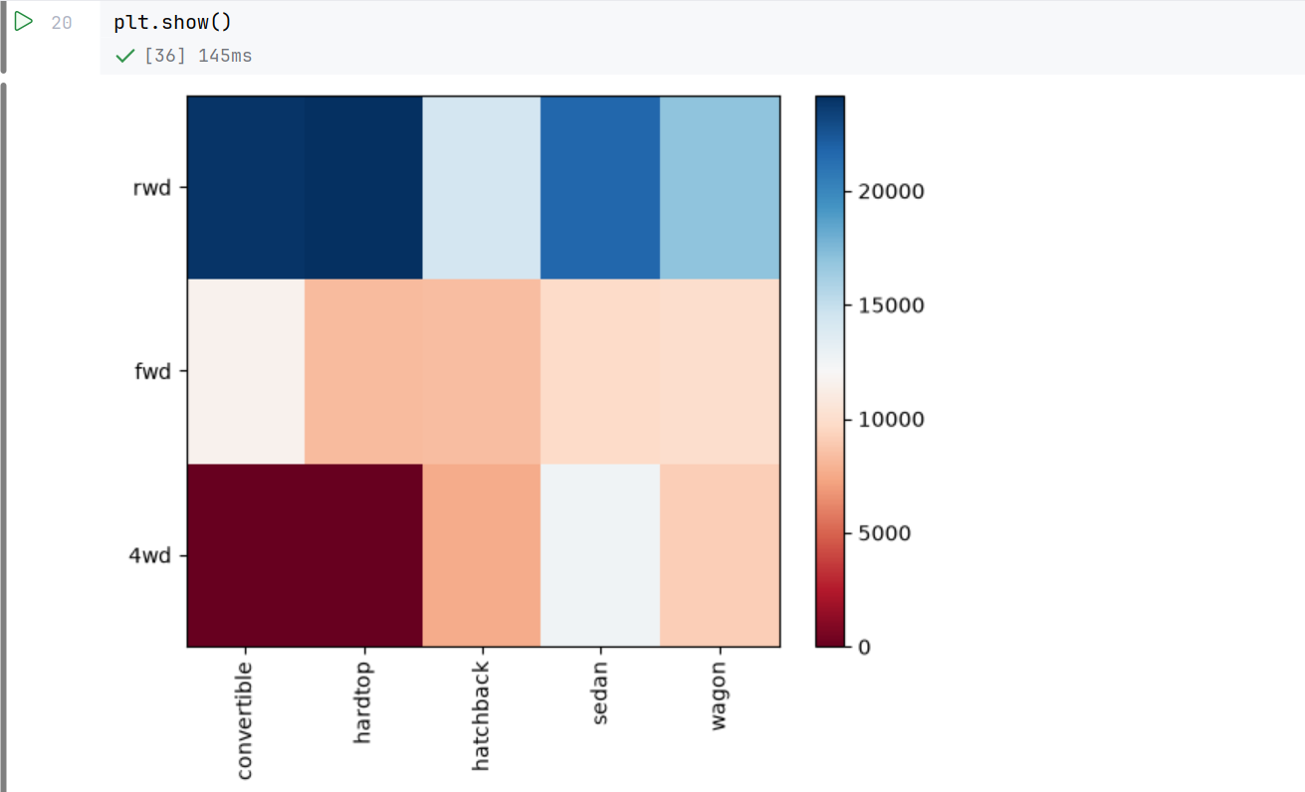
Screenshot file: 28_ax.pcolor_heatmap_with_labels_p2.png
(image width 16.4 cm, scale to fit)
The rendered figure from the previous cell, kept as the visual evidence for the grouping section.

Lab1_29. Section 5 Correlation matrix used for the variable selection
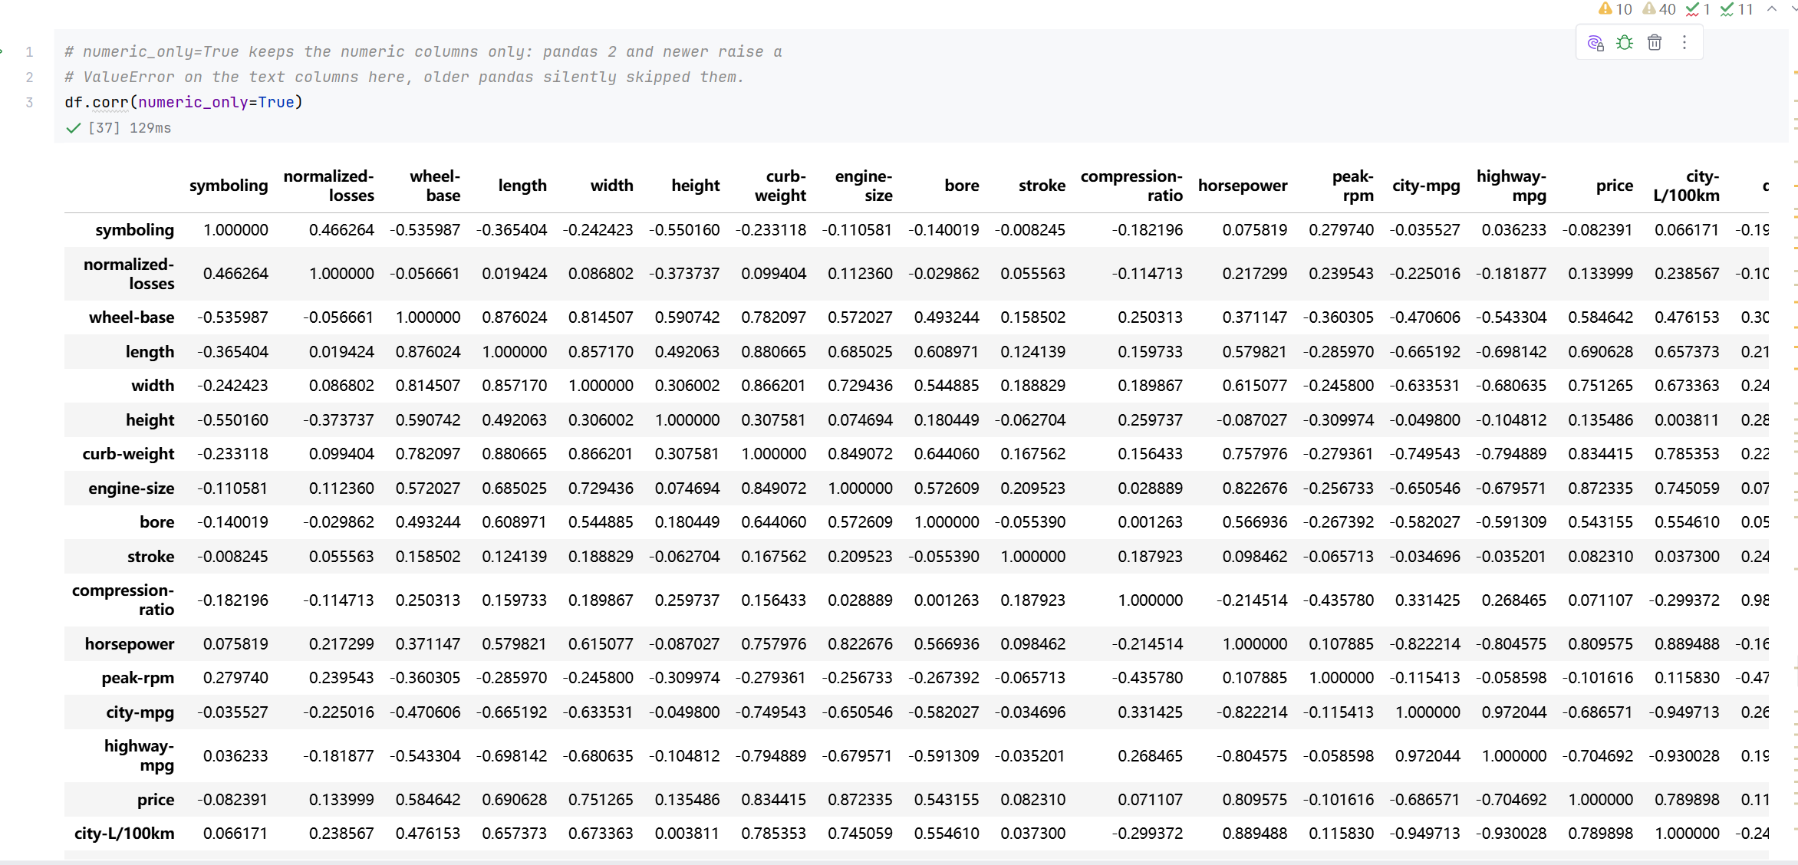
Screenshot file: 29_corr_numeric_only_p2.png
(image width 16.4 cm, scale to fit)
df.corr with numeric_only is repeated in the correlation section and is the table from which the strongest predictors of price, engine size and curb weight, are identified.

Lab1_30. Section 5 Pearson correlation and p value for wheel base
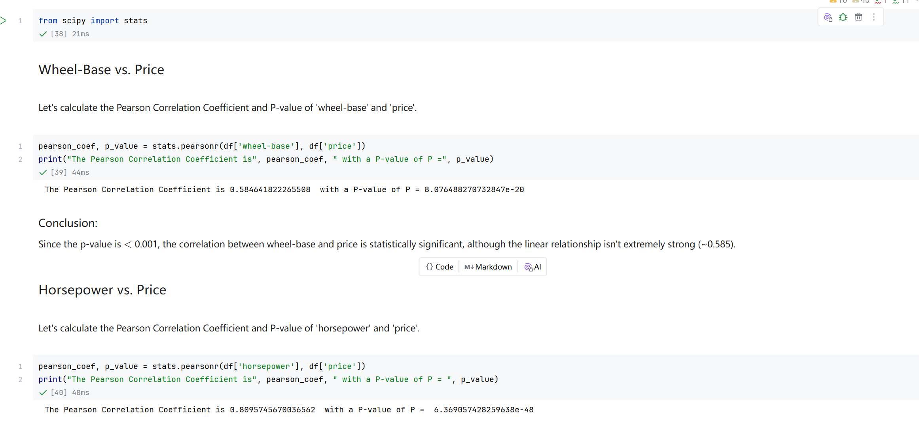
Screenshot file: 30_pearsonr_wheel-base_vs_price.png
(image width 16.4 cm, scale to fit)
stats.pearsonr for wheel-base against price returns a coefficient of about 0.585 with a p value far below 0.001, so the relationship is statistically significant but moderate.

Lab1_31. Section 5 Pearson correlation and p value for length
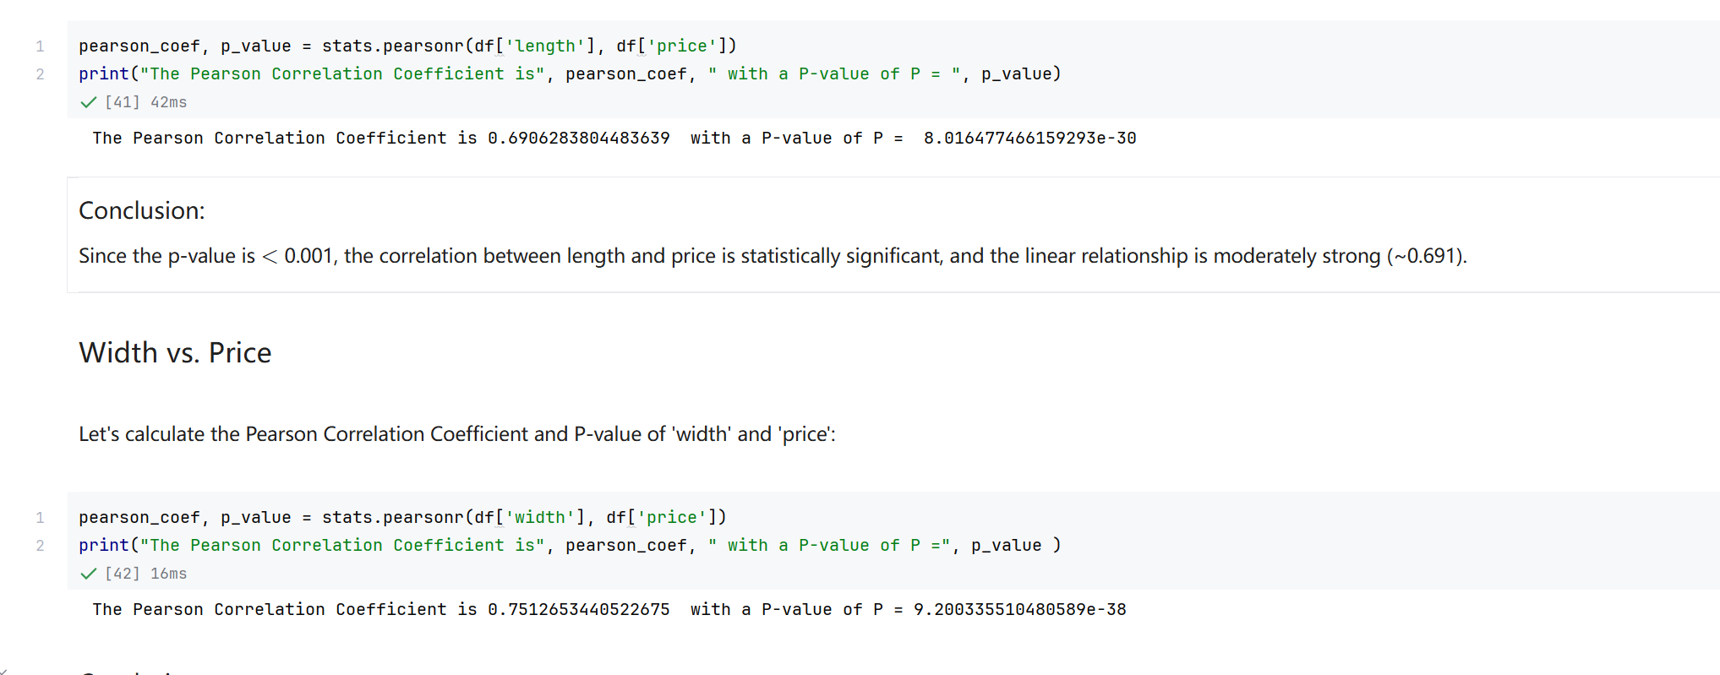
Screenshot file: 31_pearsonr_length&width_vs_price.png
(image width 16.4 cm, scale to fit)
The same test for length gives about 0.691, a moderately strong positive relationship with price.

Lab1_32. Section 5 Pearson correlation and p value for curb weight
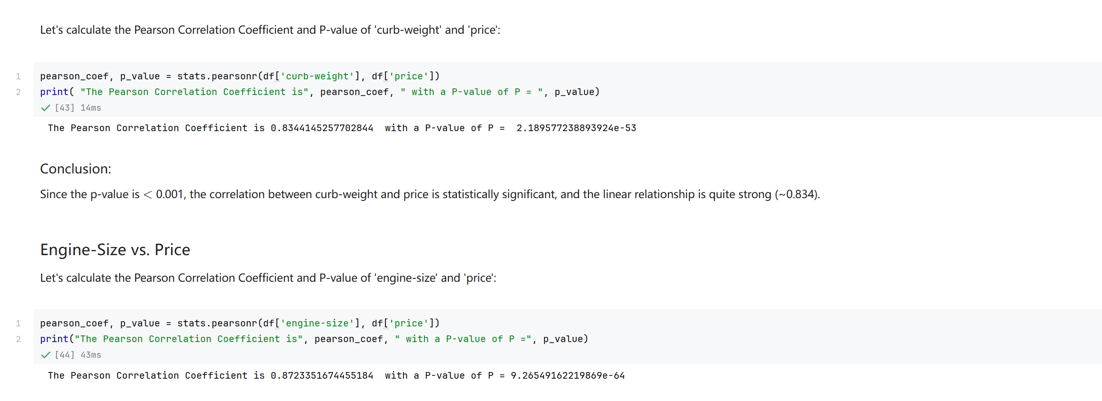
Screenshot file: 32_pearsonr_curb-weight&engine_size_vs_price.png
(image width 16.4 cm, scale to fit)
Curb weight reaches about 0.834, one of the strongest single predictors in the dataset.

Lab1_33. Section 5 Pearson correlation for bore and city mpg
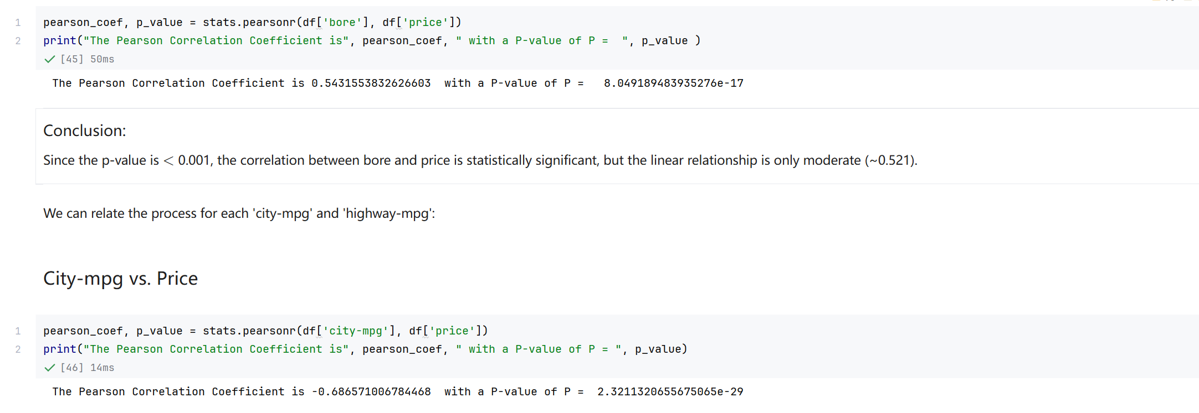
Screenshot file: 33_pearsonr_bore_and_city-mpg_vs_price.png
(image width 16.4 cm, scale to fit)
The screenshot covers the bore test, about 0.543 with a very small p value, and the start of the city mpg test, which returns about -0.687.

Lab1_34. Section 5 Pearson correlation and p value for highway mpg
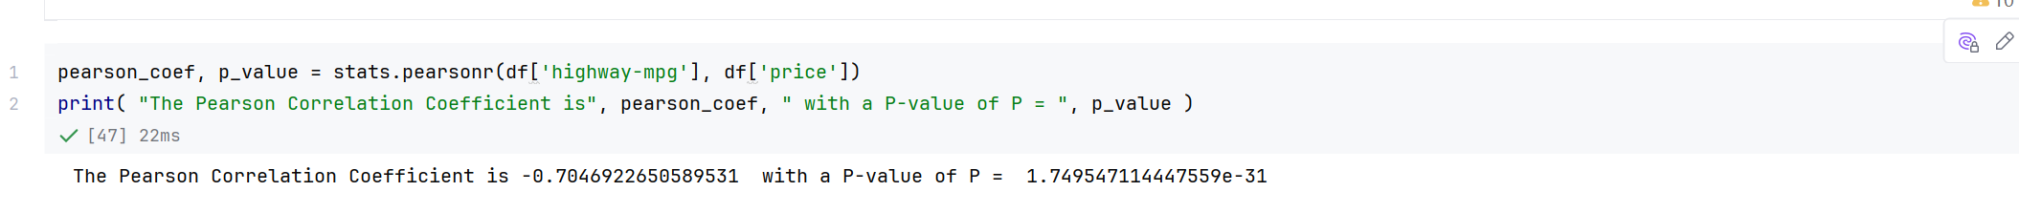
Screenshot file: 34_pearsonr_highway-mpg_vs_price.png
(image width 16.4 cm, scale to fit)
The final test gives about -0.705 for highway mpg, completing the list of variables that the notebook carries forward into model development.

